Complete a Tutorial

Deep Learning with PyTorch: A 60 Minute Blitz
Austin Yovanno
(CS_461_400_F2025)
10/27/2025

Introduction
The tutorial I chose to complete is the official PyTorch tutorial titled Deep Learning with PyTorch: A 60 Minute Blitz [1]. The tutorial consists of 4 separate mini-tutorials, with the ultimate goal being to get to know PyTorch’s Tensor library. As well to get an overview of neural networks by training a small neural network for image classification. The PyTorch website offers a few different ways to complete the tutorial. This includes Google Colab, jupyter notebooks, cloning a GitHub Repository, as well as just writing the code yourself. Originally, I started by just writing the code myself, but found the output to be a bit dense. As a result I pivoted by downloading the Jupyter notebooks, and used the jupyter lab interface. This allowed me to interact with the output in a more modular way, as well as to keep the information from the tutorial without comments cluttering up raw Python code.

Setup
Following the Get Started guide was fairly straight forward [2]. My group has discussed using the uv package manager, so I originally attempted to use that for the tutorial, but ran into issues and didn’t have the time to troubleshoot. However, I plan on completing more of the PyTorch Learn activities, and will likely give it another go.

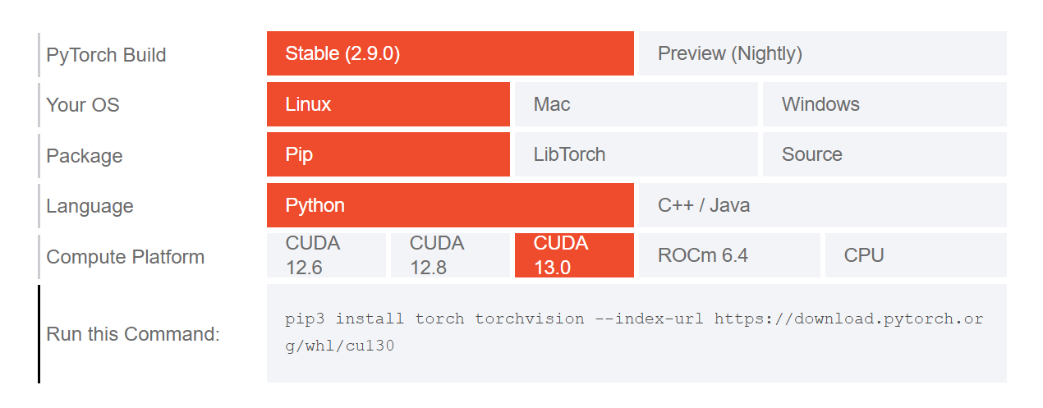
For development I prefer Linux, but Windows 11 is my base operating system. As such I was running Ubuntu 24.04.3 LTS through Windows Subsystem for Linux (WSL). Which I have found to be the most pain free method of Linux virtualization. The Get Started guide was extremely easy to follow [2]. It utilized an interactive selector that lets you pick installation settings based on your needs, and then generates a pip command that will install all the basic required packages pytorch needs.
Figure 1: PyTorch installation selector.
The only problem with the Get Started guide, was that while selecting the appropriate CUDA configuration was simple. The act of determining the correct option wasn’t identified in the guide. That being said, a quick search brought the nvidia-smi command to my attention in the form of an AI generated answer that didn’t require me to click on any links. The nvidia-smi command displayed a bunch of helpful information related to my GPU, including the fact that my GPU is using CUDA Version: 13.0.
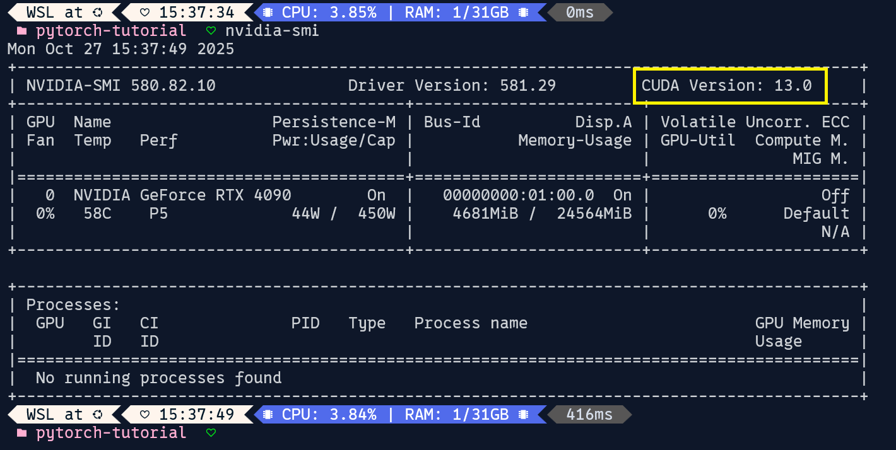
Figure 2: Output of nvidia-smi, with the CUDA Version outlined in yellow.

After receiving the command pip3 install torch torchvision --index-url https://download.pytorch.org/whl/cu130 from the selector. I then created the .venv-pytorch-tutorial virtual environment, activated it, and ensured the activation was successful with which python. Once the virtual environment was set up, I then ran the installation command, followed by pip install matplotlib notebook jupyterlab. I then downloaded the notebook files to my directory via curl.

Tensors
The first tutorial of the Blitz was simply titled Tensors [3]. As the title implies, the primary focus of this tutorial was tensors. Including how to initialize tensors, the attributes of a tensor, tensor operations, and the syntax surrounding those topics. It also outlined many of the syntactic similarities and interoperability that the torch framework shares with numpy.

Tensors and NumPy arrays share a lot of similarities, as they are both n-dimensional arrays. However, the torch framework is able to leverage the power from a GPU. This was demonstrated through the use of the tensor.device attribute. After initializing a tensor named tensor, a print() function was called to see the tensor.device, where we saw that it was initially stored on the CPU. After which, we saw that by utilizing the tensor.to() function we were able to store tensor on a CUDA core.
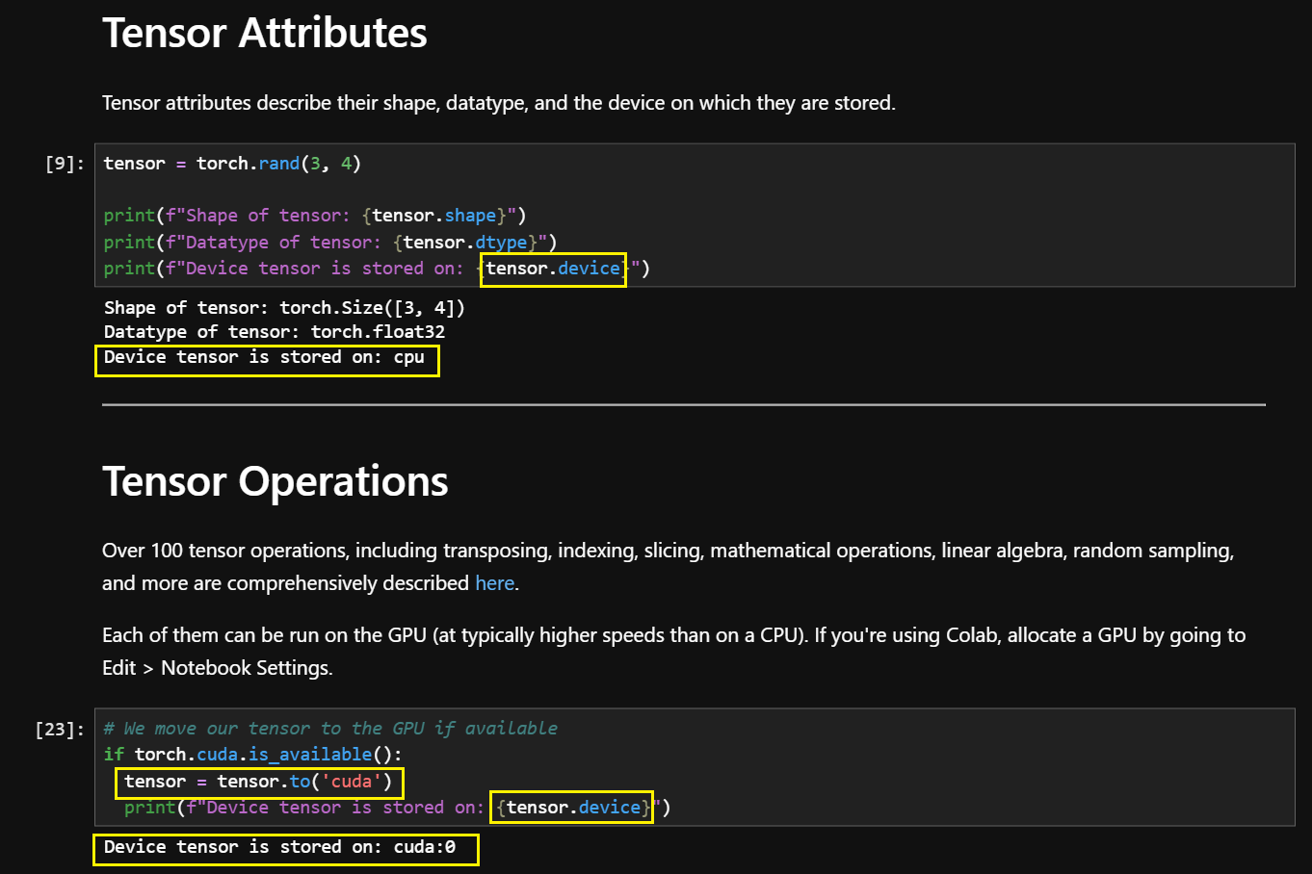
Figure 3: Screenshot from the Tensors Jupyter Notebook, with tensor.device, related operations, and output outlined in yellow.

A Gentle Introduction to torch.autograd
The tutorial A Gentle Introduction to torch.autograd introduces PyTorch’s automatic differentiation engine. Which is the backbone of neural network training. The tutorial takes a very high level view of training a neural network. It discusses both the logic and the syntax of what the torch framework is doing behind the scenes. In the tutorial we load a pretrained model from torchvision, and then walk through a singular instance of forward and backward propagation.

A random tensor named data is initialized and then passed into the model(), the output of which is stored as a prediction of what the neural network believes to be the correct output. Which is then used to calculate the error tensor. This error tensor then calls the .backward() function which then corrects the errors and saves the information model.parameters() in its respective .grad attribute. Next the information is loaded into an optimizer and saved as optim. optim.step() is then called to adjust the weights of the neural network to improve future model accuracy.
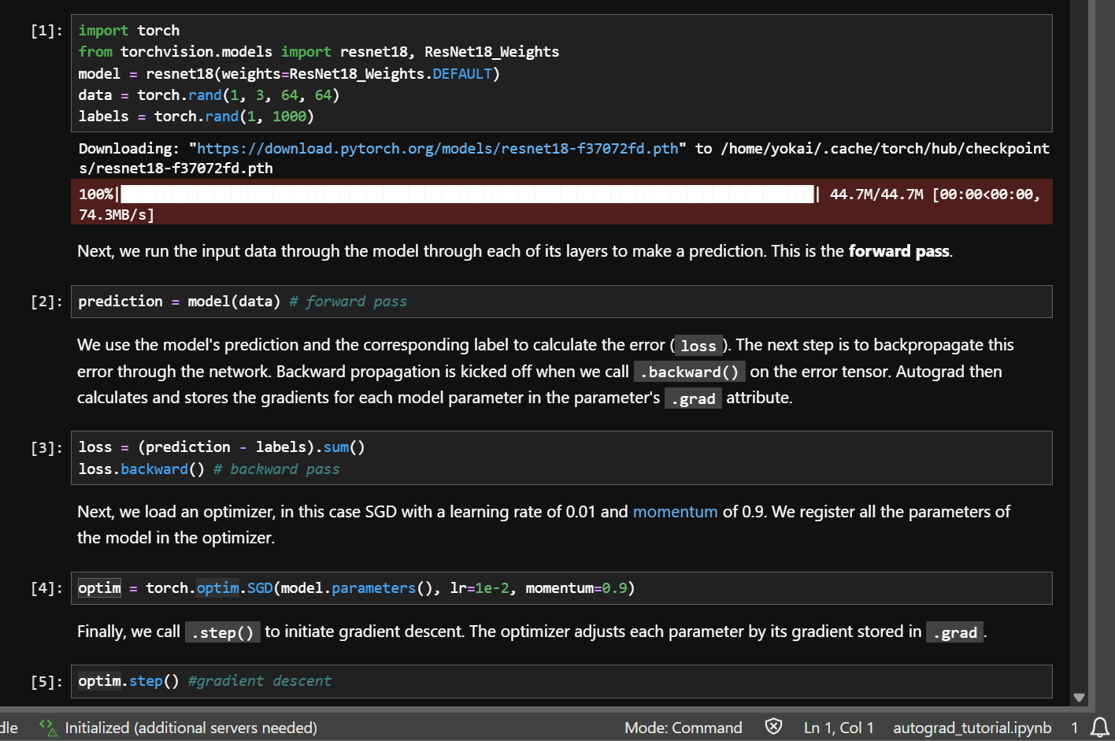
Figure 4: Screenshot showing the completed forward and backward propagation in the Jupyter Notebook.

Neural Networks
The Neural Networks tutorial goes into greater detail about neural networks using torch.nn. Whereas the previous section discussed a singular step, this section dove into the initialization of a neural network. The neural network for the tutorial creates a class named Net which is a subclass of the torch.nn module. It only consists of two functions, an __init__ function, the forward() function. A function for backward propagation isn’t needed as it is already provided by torch.autograd. We then initiate an instance of the network with net = Net(). Following which we view its parameters, and then test some sample input.

The tutorial then walks us through the use of a loss function from torch.nn to calculate the margin of error, as well as the ability to print the loss. Following the loss calculation we then call loss.backward() , just like the previous section. We are also able to get a look at what is actually happening by printing the .grad attribute of the models parameters.
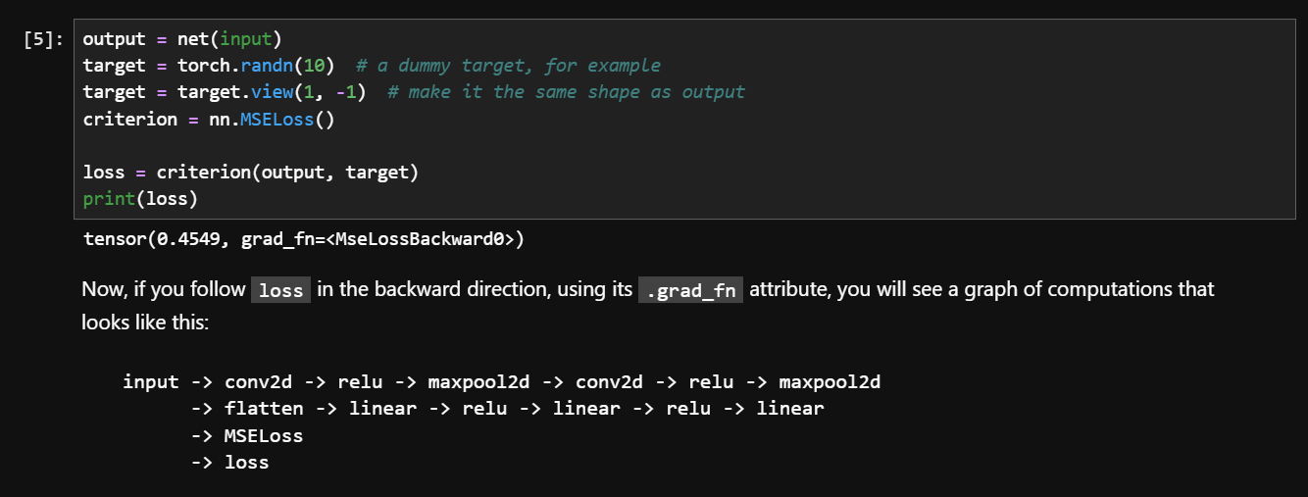
Figure 5: Screenshot showing the code for calculating loss, as well as the output from when the code was ran in the Jupyter Notebook.

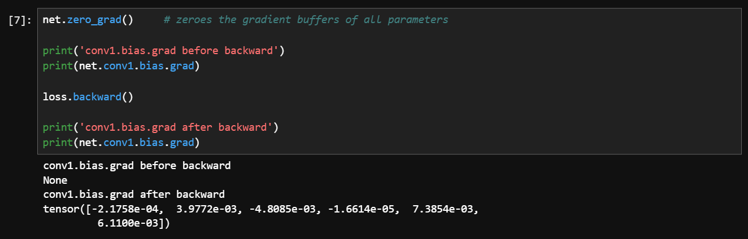
Figure 6: Screenshot showing the result of zeroing out the neural networks gradients, followed by the data that populates after running loss.backward().

Training a Classifier
In the Training a Classifier section of the tutorial, we are able to put together everything we did in the previous sections [6]. The first step of which is to grab a dataset of images and transform them into tensors that can be fed into the neural network. After which the Net() class from the previous section is converted to have 3-channel images. Similar to the previous sections we also then defined a loss function, as well as an optimizer.

We then use a for loop to iterate through the dataset. Inside this for loop we put together the steps we have discussed previously. Namely, we zero the parameter gradients, then pass the data through forward propagation, backward propagation, optimize, and repeat. We then save the model and test it to see how accurate it is in total, and then also analyze how accurate it was by category.
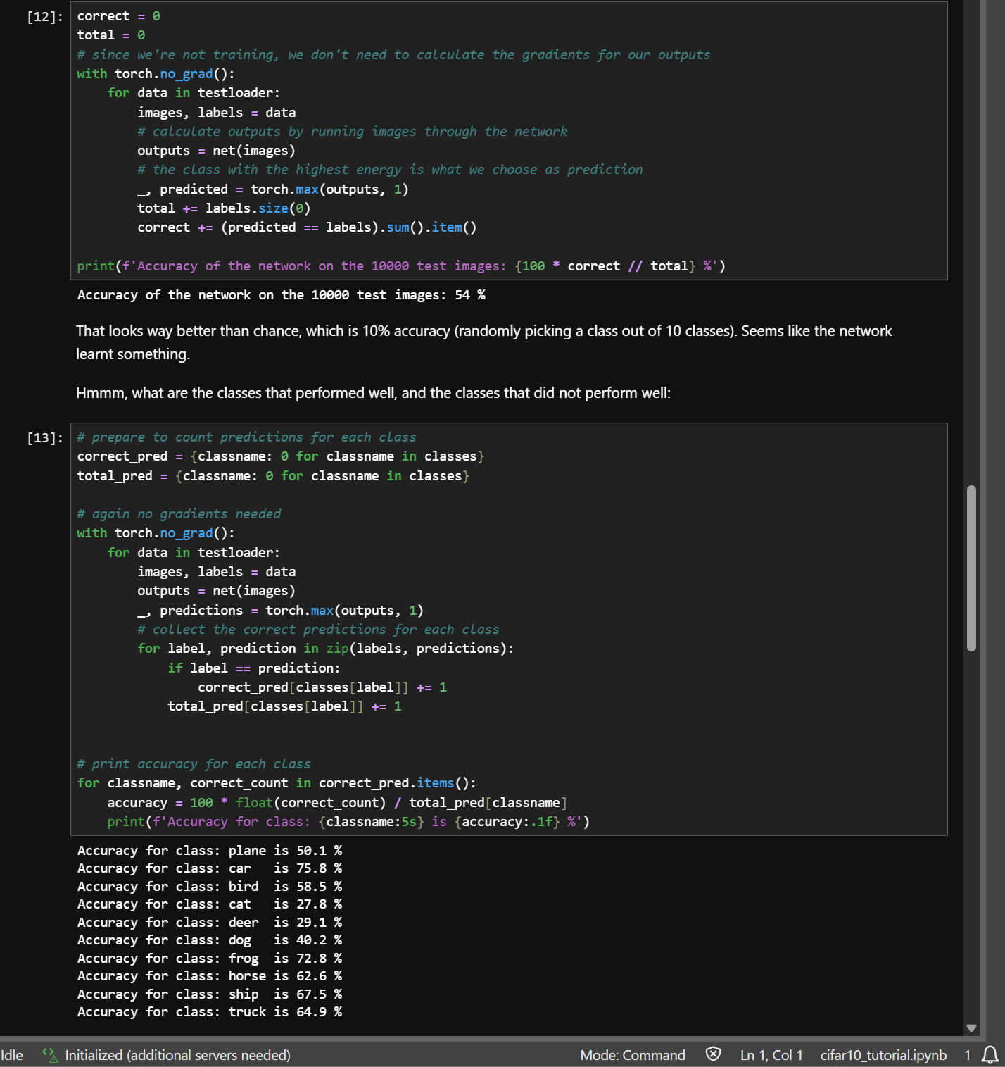
Figure 7: Screenshot of the results testing the model from the Jupyter notebook. The accuracy over 10,0000 images was 54%. While the most accurate category was car with an accuracy of 75.8%, and the least accurate category was cat with an accuracy of 27.8%.

Conclusion
This activity was a crucial step in my understanding how aspects of our project will function. PyTorch is a completely new framework for me, and getting some first hand experience with it really helped me understand some concepts, which up until now have been extremely nebulous to me. In the project portal PyTorch was listed as something we were required to get familiar with, and I see why. The framework provides the tools to handle complicated calculations, and in a way provides a bit of a roadmap for what we need to build our model. The PyTorch website also has many more tutorials, as well as thorough documentation which will benefit our project in the long run.

References

[1] | P. Contributors, “Deep Learning with PyTorch: A 60 Minute Blitz,” Jan. 01, 2023. https://docs.pytorch.org/tutorials/beginner/deep_learning_60min_blitz.html
[2] | “Get started,” PyTorch. https://pytorch.org/get-started/locally/
[3] | P. Contributors, “Tensors,” Jan. 01, 2023. https://docs.pytorch.org/tutorials/beginner/blitz/tensor_tutorial.html
[4] | P. Contributors, “A Gentle Introduction to torch.autograd,” Jan. 01, 2023. https://docs.pytorch.org/tutorials/beginner/blitz/autograd_tutorial.html
[5] | P. Contributors, “Neural networks,” Jan. 01, 2023. https://docs.pytorch.org/tutorials/beginner/blitz/neural_networks_tutorial.html
[6] | P. Contributors, “Training a classifier,” Jan. 01, 2023. https://docs.pytorch.org/tutorials/beginner/blitz/cifar10_tutorial.html

